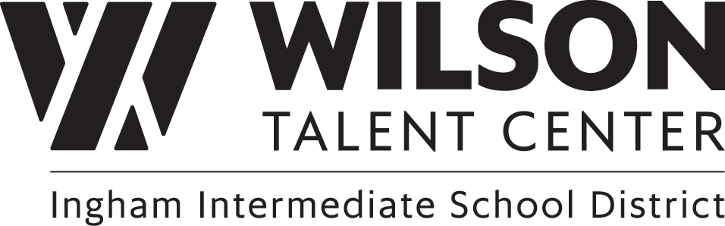

State and National Offered Certifications for the 2025-26 School Year

Program/Certification | State or National | Number Achieved
Automotive Technology
ASE Maintenance & Light Repair | National
ASE Engine Repair | National
ASE Automatic Transmission | National
ASE Manual Transmission & Driveline | National
ASE Suspension & Steering | National
ASE Brakes | National
ASE Electrical/Electrical Systems | National
ASE Heating and Air Conditioning | National
ASE Engine Performance | National
SOM Engine Repair | State
SOM Automatic Transmission | State
SOM Manual Transmission & Driveline | State
SOM Suspension & Steering | State
SOM Brakes | State
BioScience Careers
AMSA Food Safety & Science Certification | National
Bayer CropScience Plant Science | National
Southwest Airlines Professional Communications Certification | National
Elanco Veterinary Medical Applications | National
Equine Management Certification | National
Personal Financial Literacy Certification | National
Ducks Unlimited Ecology Conservation & Management | National
Principals of Floral Design | National
Livestock Management | National
OSHA 10-HR General Industry Safety | National
BioScience Core Skills Institute (BCSI) Micro-credentials | National
Business & Risk Mgmt.
Certified Insurance Services Representative Designation | National
Property/Casualty Licensing (Yr. 2, when 18) | National
Life/Health Licensing (Yr. 2, when 18) | National
InVEST Insurance Curriculum Certificate | National
Certified Authority on Worker’s Compensation (CAWC) | National
Career Start
OSHA 10 General | National
OSHA 10 in Construction, Cosmetology, Healthcare, Automotive, Agriculture and/or Manufacturing | National
Keyboarding | Neither
Ladder Safety | National
CPR/AED | National
ServSafe | National
Sexual Harassment | National
Bloodborne Pathogens | National
Cybersecurity – safety online | National
Construction Trades
OSHA 10 Construction Certification | National
Skilled to Build Michigan Foundation Residential Construction Skills | State
Cosmetology
Milady Infection Control Certification | National
Barbicide Certification | National
Barbicide Be-Healthy Certification | National
Milady Human Trafficking Awareness Certification | National
Milady Domestic Abuse Awareness Certification | National
Shear Haven Domestic Abuse Awareness Certification | National
Milady Rise Certification | National
Criminal Justice
CPR/AED | National
First Aid | National
National Basic 911 Dispatch | National
Culinary Arts & Hospitality
ServSafe Food Protection Manager – 5 year | National
CPR & First Aid – 2 year | National
Foundations of Culinary Arts & Hospitality Mgmt. Level 1 | National
Foundations of Culinary Arts & Hospitality Mgmt. Level 2 | National
ServSafe Allergen | National
ServSafe Alcohol Server Training | State
Cybersecurity & Digital Forensics
Cisco Certified Support Technician (CCST) IT Support | National
CompTIA Tech + | National
CompTIA A+ (limited students) | National
Cisco Certified Support Technician (CCST) Cybersecurity | National
Cisco Certified Support Technician (CCST) Networking | National
CompTIA Network + | National
CompTIA Security + (limited students) | National
Educational Careers
CPR/First Aid | National
Child Development Associate (CDA) | National
Youth Development Associate (Mi-YDA) | State
Engineering Technologies
Certified SolidWorks Associate (CSWA) | National
Cyber Ambassadors – Leadership, Communication & Teamwork | National
Health Foundations
CPR/AED | National
First Aid | National
OSHA Healthcare Certification | National
Stop the Bleed | National
Seizure First Aid | National
Manicurist
Milady Infection Control Certification | National
Barbicide Certification | National
Barbicide Be-Healthy Certification | National
Milady Human Trafficking Awareness Certification | National
Milady Domestic Abuse Awareness Certification | National
Shear Haven Domestic Abuse Awareness Certification | National
Milady Rise Certification | National
Medical Assistant
Clinical Medical Assistant (CCMA) | National
Phlebotomy Technician (CPT) | National
Pharmacy Technician (CPhT) | National/State
CPR – American Heart Association | National
First Aid – American Heart Association | National
New Media
Adobe | National
Patient Care Technician (PCT)
Patient Care Technician/Assistant (CPCT/A) | National
EKG Technician (CET) | National
Phlebotomy Technician (CPT) | National
Certified Electronic Health Records Specialist (CEHRS | National
Precision Machining Technology
OSHA 10 Hour Certification | National
Mastercam 3D Mill Certification (Yr. 2 only) | National
Programming & Mobile Applications
Certiport IT Specialist – Java | National
Certiport IT Specialist - Python | National
Certiport IT Specialist - Databases | National
Comptia A+ | National
Sports Medicine & Rehabilitation
NASM Certified Personal Trainer | National
AMCA Physical Therapy Technician Certification (PTTC) | National
Welding Technology
OSHA 10 Hour General | National
American Welding Society | National

Updated: 5.27.26

