How to Use
Google Classroom

Google Classroom is an online platform that we use in class and can be accessible from home. Our students may log-in and complete assignments, view documents/links pushed out from me, and review materials that are important.
How to log in: If you use google chrome as your default browser, open a new tab and locate the “google apps” drop down in the upper right hand corner of your screen. This is the square with 9 dots (that looks like a waffle). If you are not already logged in, you will see a “sign in” button and will need to log in.
If you do not have google chrome as your default browser, simply search “google.com” and the same screen will appear. Once you’ve reached the sign in screen, enter your student’s hpsk12 email address. Ex: zz1111@hpsk12.net 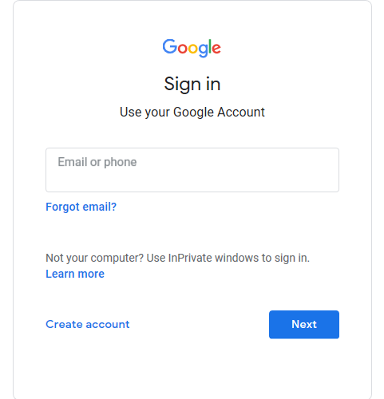
From there, you will be prompted to re-enter your student’s credentials on this screen: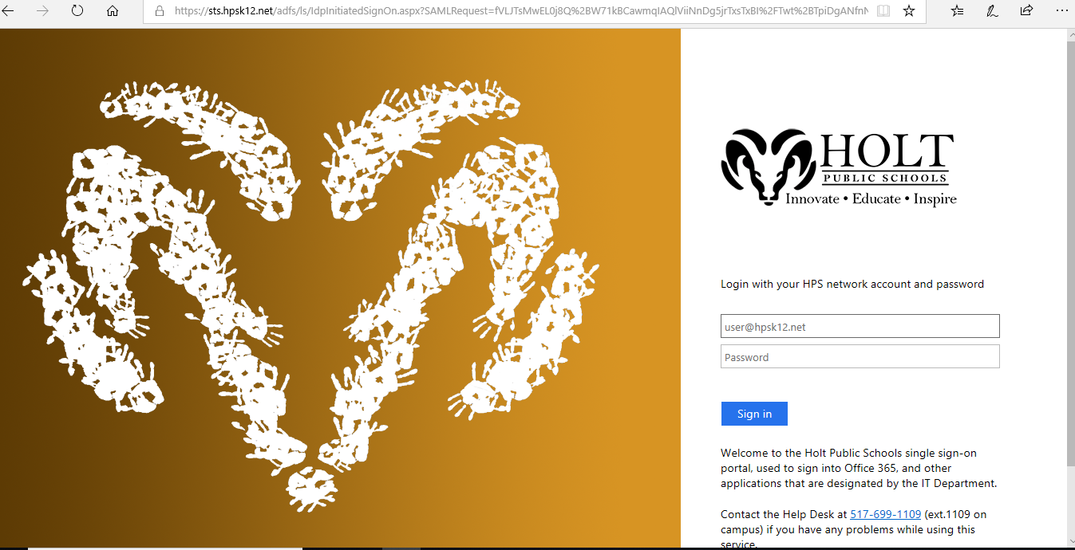

*It will be their hpsk12 email address and password. Press “sign in” when done.
Ex: zz1111@hpsk12.net password: 12345

Once you’re logged in, and have clicked the google apps drop down, select “classroom”.

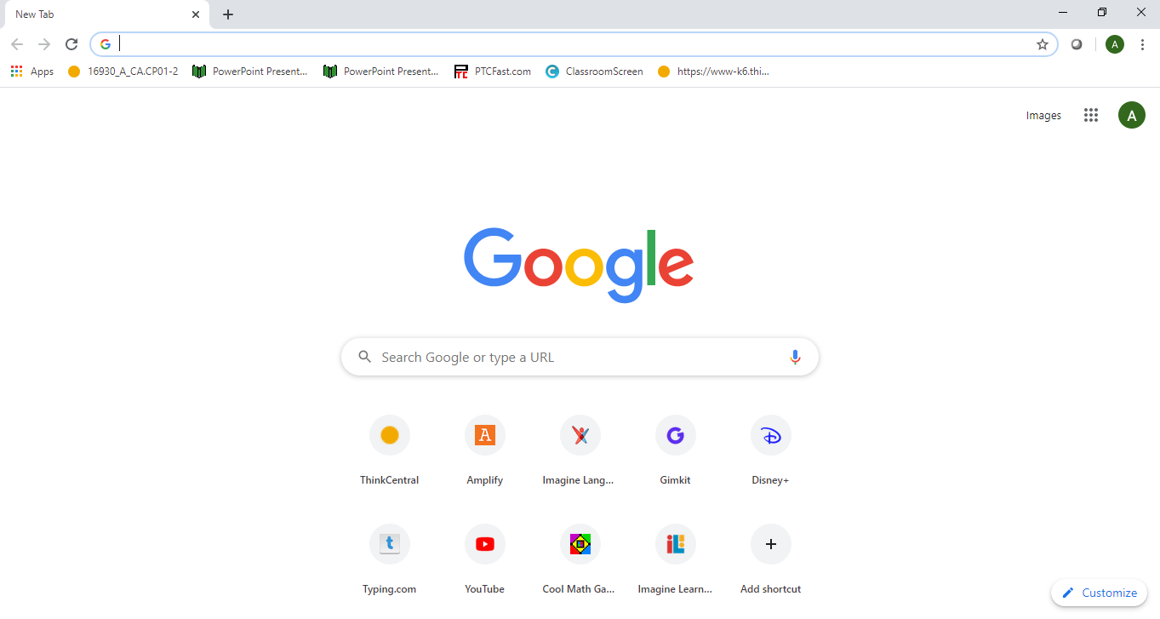

You will be prompted to select “Team 116” – do that.

The Stream is our “home page”. Here you can find any comments or directions that I may give to the class. The top of the screen is the most recent. For instance, I may assign new work for students to complete and leave a post to remind them. You can also access many of the assignments from the stream.

Classwork is the section where you’ll find most assignments I push out. To access, click on the assignment → view assignment → and proceed to the next screen. There will be a set of directions to go along with the assignment description.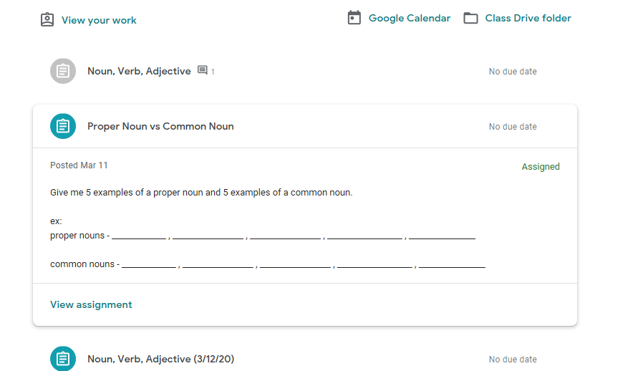

Once your student has clicked “view assignment”, have them select the “+add or create” option on the upper right hand side of the screen. There may be assignments where I include the document. In that case, students will not have to “+add or create”.
*A drop down list will appear – have them choose “docs”*

Give the computer a minute to load their doc and you will see their doc appear on the right hand side of the screen. Have your student select their doc and a new tab will open with their assignment.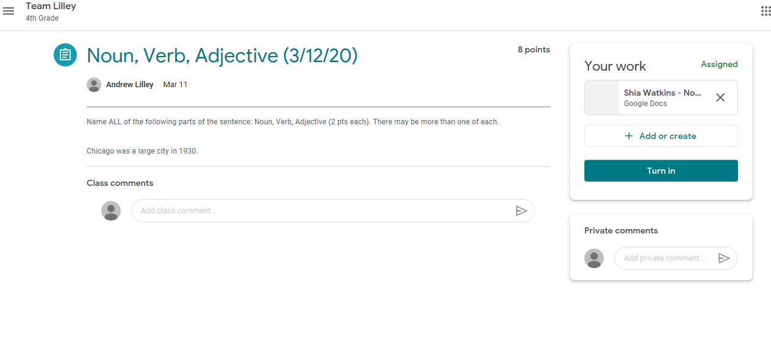
Once completed, there is a “Turn In” button at the top right hand side of the screen. Have them turn in the assignment and I will receive their completed work to grade and leave comments.

If you have any questions, don’t hesitate to email, text or call:

tcotter@hpsk12.net
517-290-0241

